**Worksheet 25**

1. Let *D* be a square . Evaluate 

1. Let *C* be , evaluate 

**Hint**: create closed curve , use green theorem to calculate then .

1. 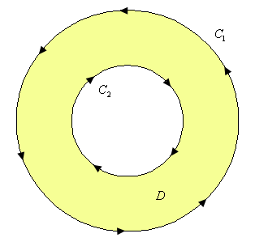Evaluate  where C are the two circles of radius 2 and radius 1 centered at the origin with positive orientation.
2. Let,





1. Let  and 



1. Verify Stoke’s theorem on  over the surface S: 
2. 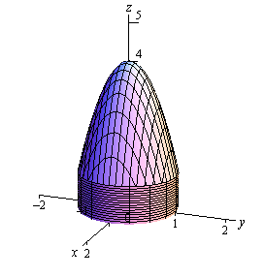Let  and S defined by on top,  on sides and z=0 at the bottom.

