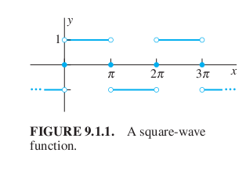

f(x)=(-1)pulse(x,-pi,0) +(1)pulse(x,0,pi)

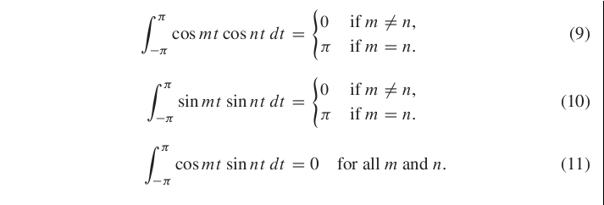
Properties of the inner product <f,g> = integral of f(x)g(x) over -pi to pi.
(a) <f,g>=<g,f>
(b) <f,f> nonegative; <f,f>=0 <==> f=0 (continuous f)
(c) c<f,g>=<cf,g>=<f,cg>
(d) <f+g,h>=<f,h>+<g,h>

Example 1: 9.3 f(x)=t*pulse(t,0,L), find Fourier Sine and Cosine series

These are the regular Fourier series of the ODD extension fO(t)=t*pulse(t,0,L)+(-t)*pulse(t,-L,0)
and the EVEN extension fE(t)=t*pulse(t,0,L)+(t)*pulse(t,-L,0).

FE: a[0]=L, a[2k]=0, a[2k+1]= -4L/((2k+1)^2Pi^2) FO: a[n]=0, b[n]=(2L/(nPi))(-1)^n


