Lesson Plan Transformational Geometry Shae Yeates
Extension for Rotation and Reflection SMI Honors:
Standards:
HONORS - Standard N.VM.8 Add, subtract, and multiply matrices of appropriate dimensions.
Standard G.CO.5
Given a geometric figure and a rotation, reflection, or translation, draw the transformed figure using, for example, graph paper, tracing paper, or geometry software. Specify a sequence of transformations that will carry a given figure onto another. Point out the basis of rigid motions in geometric concepts, for example, translations move points a specified distance along a line parallel to a specified line; rotations move objects along a circular arc with a specified center through a specified angle.
Prior Knowledge: Students already know matrices, vectors, rotations and reflections. Have a basic understanding of the unit circle and sin, cos, and tan.
Objective: students will be able to use the rotation matrices to rotate points on a graph.
Starter: Please apply the following transformations to the triangle $\left(1,3\right), \left(2,1\right), (4,4)$
- Rotate $180°→\left(-1,-3\right), \left(-2,-1\right),(-4,-4)$
- Rotate $90°→\left(-3,1\right), \left(-1,2\right), \left(-4,4\right)$
Have students work on this starter.
Lesson:
- Give a few more examples that are easily found by rotating their plane. (270, 0)
- Now give them 30$°$ and 45$°$.
- Let them try for a few minutes and walk around and see what they are doing.
- NOTES:
We are limited when we just memorize the coordinates when we rotate $90°, 180°, and 270°$. We are going to use a new matrix so that we can rotate any point any degrees around the origin!!
$$\left[\begin{matrix}\cos{θ} & -\sin{θ} \\ \sin{θ} & \cos{θ}\end{matrix}\right]$$
In order to use this matrix to find new points what can we do to? *hint it has something to do with vectors*
Change the following points into vectors:
$$\left(1,3\right)$$ | $$\left(2,1\right)$$ | $$(4,4)$$
$$\left[\begin{aligned}1 \\ 3\end{aligned}\right]$$ | $$\left[\begin{aligned}2 \\ 1\end{aligned}\right]$$ | $$\left[\begin{aligned}4 \\ 4\end{aligned}\right]$$

We are going to multiply these three points to rotate our triangle $180°$ so we can see if this works. (since we know the answers from the starter.)
$$\left[\begin{matrix}\cos{180} & -\sin{180} \\ \sin{180} & \cos{180}\end{matrix}\right]\left[\begin{aligned}1 \\ 3\end{aligned}\right]=\left[\begin{matrix}-1 & 0 \\ 0 & -1\end{matrix}\right]\left[\begin{aligned}1 \\ 3\end{aligned}\right]=\left[\begin{aligned}-1 \\ -3\end{aligned}\right]→(-1,-3)$$
*walk students through this first problem and then have them practice on their own. The next two*
$$\left[\begin{matrix}\cos{180} & -\sin{180} \\ \sin{180} & \cos{180}\end{matrix}\right]\left[\begin{aligned}2 \\ 1\end{aligned}\right]=\left[\begin{matrix}-1 & 0 \\ 0 & -1\end{matrix}\right]\left[\begin{aligned}2 \\ 1\end{aligned}\right]=\left[\begin{aligned}-2 \\ -1\end{aligned}\right]→\left(-2,-1\right)$$
$$\left[\begin{matrix}\cos{180} & -\sin{180} \\ \sin{180} & \cos{180}\end{matrix}\right]\left[\begin{aligned}4 \\ 4\end{aligned}\right]=\left[\begin{matrix}-1 & 0 \\ 0 & -1\end{matrix}\right]\left[\begin{aligned}4 \\ 4\end{aligned}\right]=\left[\begin{aligned}-4 \\ -4\end{aligned}\right]→\left(-4,-4\right)$$
Have students now practice with rotating it $90°$
$$\left[\begin{matrix}\cos{90} & -\sin{90} \\ \sin{90} & \cos{90}\end{matrix}\right]\left[\begin{aligned}1 \\ 3\end{aligned}\right]=\left[\begin{matrix}0 & -1 \\ 1 & 0\end{matrix}\right]\left[\begin{aligned}1 \\ 3\end{aligned}\right]=\left[\begin{aligned}-3 \\ 1\end{aligned}\right]→(-3,1)$$
$$\left[\begin{matrix}\cos{90} & -\sin{90} \\ \sin{90} & \cos{90}\end{matrix}\right]\left[\begin{aligned}2 \\ 1\end{aligned}\right]=\left[\begin{matrix}0 & -1 \\ 1 & 0\end{matrix}\right]\left[\begin{aligned}2 \\ 1\end{aligned}\right]=\left[\begin{aligned}-1 \\ 2\end{aligned}\right]→\left(-1,2\right)$$
$$\left[\begin{matrix}\cos{180} & -\sin{180} \\ \sin{180} & \cos{180}\end{matrix}\right]\left[\begin{aligned}4 \\ 4\end{aligned}\right]=\left[\begin{matrix}0 & -1 \\ 1 & 0\end{matrix}\right]\left[\begin{aligned}4 \\ 4\end{aligned}\right]=\left[\begin{aligned}-4 \\ 4\end{aligned}\right]→\left(-4,4\right)$$
Now have students rotate those same points around different angles: $30°, 135°, 240°$.
Finish by having students draw a figure with 3 or more points and rotate around a degree that is not $90°, 180°,$or$270°$.
Hand out homework and have student ask questions before the end of class.

SM1 Honors Notes Rotation Matrix
Right now, we can rotate any figure: (put the degree and the rule):

We are going to be using a matrix to now rotate our point any degree value we want using the following matrix: ______________________________________________
$$\left[\begin{matrix}\begin{matrix}\begin{matrix}\begin{matrix}\frac{}{} & \frac{}{}\end{matrix} \\ \begin{matrix}__________________ & __________________\end{matrix}\end{matrix} \\ \begin{matrix}\frac{}{} & \frac{}{2}\end{matrix}\end{matrix} \\ \begin{matrix} __________________ & __________________\end{matrix} \end{matrix}\right]$$
In order to use this matrix to find the new points we must first remember how to change a point into a vector: change the following points into vectors.
$$\left(1,3\right)$$ | $$\left(2,1\right)$$ | $$(4,4)$$

Use this matrix to find the following:
Rotate $(1,3)$ $180°$
Rotate $(2,1)$ $180°$
Rotate $(4,4)$ $180°$

Does that follow the rule we had earlier? ______________________
Use the matrix to double check the rules:
Rotate $(1,3)$ $90°$
Rotate $(2,1)$ $90°$
Rotate $(4,4)$ $90°$

Did this follow the rule? _____________

Since we have found that this matrix works lets try new angles:
Find the new points for the triangle $\left(1,3\right), \left(2,1\right),$ and $(4,4)$ for the following rotations:
Rotate $30°$
Rotate $135°$
Rotate $240°$

Create your own shape of 3 or more points and rotate it any amount (other than $90°, 180°,$or$270°$). Show your work with the rotation matrix.
Original:  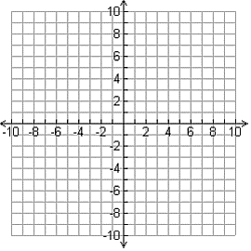 | Rotated image:

Name ___________________________________ Period _______________ Date Due _______________
Rotation Matrix Homework
Directions: Please rotate at least three points using the rotation matrix and write the new points rounded to the nearest hundredth. SHOW ALL YOUR WORK.
- Rotation $60°$: $A= , B= , C=$
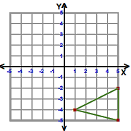
- Rotation $120°: A= , B= , C=$
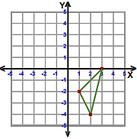
- Rotate $225°$: $A= , B= , C=$
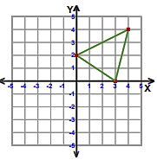
- Rotate $330°$: $A= , B= , C=$
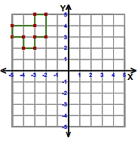
- Rotate $30°$: $A= , B= , C=$
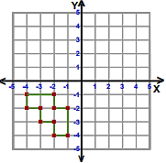
- Rotate $45°$: $A= , B= , C=$
