Merilee Gandy
Lesson Plan for Math 5270

Application of Rotation and Reflection Matrices
Secondary II – 10th grade Honors
Objective:
Students will be able to rotate and reflect an image at any degree or radian
Prior Knowledge:
- 9th grade student learn transformation rules for reflection and rotation, basic vector and matrix operations, matrices inverse and determinant, and solving equations using matrices.
- 10th grade students learn converting a radian to a degree and vice versa, trigonometric identities, trigonometric function and using them to find the angles and sides of right triangles.
Recall:
Students will need to be reminded of the following before meeting the objective:
- Transformations rules for reflection and rotation
- Multiplying matrices and finding inverses for matrices
- Using the unit circle to identify $sinθ$ and $cosθ$ in degrees or radians
Starter:
Multiply the following matrices:

$$\left[\begin{matrix}1 & 2 \\ 3 & 4\end{matrix}\right]\left[\begin{matrix}5 \\ 6\end{matrix}\right]$$

Show the students how to multiply the matrices above and then have them multiply a pair of 2x2 matrices

$$\left[\begin{matrix}1 & 2 \\ 3 & 4\end{matrix}\right]\left[\begin{matrix}5 & 6 \\ 7 & 8\end{matrix}\right]$$

Transformation Rules

Reflection:
$$x-axis: \left(x,-y\right)$$
$y-axis:$ $\left(-x,y\right)$
$y=x:$ $\left(y,x\right)$
$$y=-x:(-y,-x)$$

Rotation:
$$90°:\left(-y,x\right)$$
$$180°:\left(-x,-y\right)$$
$$270°:(y,-x)$$

Question:
Write a list of the reflection and rotation transformation rules and ask, Is it possible to rotate or reflect at anything other than the seven rules listed? How would we do this? How is it related to matrices?

Have the students ponder these questions and then show the unit circle and a picture of a rotation and explain how to get a matrix for any rotation.

Write a Matrix for each of the following rules:
$$x-axis:$$  $$\left(x,-y\right)$$ | $y-axis:$ $\left(-x,y\right)$ | $y=x:$ $\left(y,x\right)$ | $$y=-x:$$  $$(-y,-x)$$ | $$90°:\left(-y,x\right)$$ | $$180°:\left(-x,-y\right)$$ | $$270°:(y,-x)$$
$$\left[\begin{matrix}1 & 0 \\ 0 & -1\end{matrix}\right]$$ | $$\left[\begin{matrix}-1 & 0 \\ 0 & 1\end{matrix}\right]$$ | $$\left[\begin{matrix}0 & 1 \\ 1 & 0\end{matrix}\right]$$ | $$\left[\begin{matrix}0 & -1 \\ -1 & 0\end{matrix}\right]$$ | $$\left[\begin{matrix}0 & -1 \\ 1 & 0\end{matrix}\right]$$ | $$\left[\begin{matrix}-1 & 0 \\ 0 & -1\end{matrix}\right]$$ | $$\left[\begin{matrix}0 & 1 \\ -1 & 0\end{matrix}\right]$$

Practice using Reflection and Rotation Matrices:
Using the point $(3,2)$ or $\left[\begin{matrix}3 \\ 2\end{matrix}\right]$, complete the transformation by multiplying the matrices.
$$x-axis:$$  $$\left(x,-y\right)$$ | $y-axis:$ $\left(-x,y\right)$ | $y=x:$ $\left(y,x\right)$ | $$y=-x:$$  $$(-y,-x)$$ | $$90°:\left(-y,x\right)$$ | $$180°:\left(-x,-y\right)$$ | $$270°:(y,-x)$$
$$\left[\begin{matrix}1 & 0 \\ 0 & -1\end{matrix}\right]$$ | $$\left[\begin{matrix}-1 & 0 \\ 0 & 1\end{matrix}\right]$$ | $$\left[\begin{matrix}0 & 1 \\ 1 & 0\end{matrix}\right]$$ | $$\left[\begin{matrix}0 & -1 \\ -1 & 0\end{matrix}\right]$$ | $$\left[\begin{matrix}0 & -1 \\ 1 & 0\end{matrix}\right]$$ | $$\left[\begin{matrix}-1 & 0 \\ 0 & -1\end{matrix}\right]$$ | $$\left[\begin{matrix}0 & 1 \\ -1 & 0\end{matrix}\right]$$
$$\left[\begin{matrix}1 & 0 \\ 0 & -1\end{matrix}\right]\left[\begin{matrix}3 \\ 2\end{matrix}\right]=\left[\begin{matrix}3 \\ -2\end{matrix}\right]$$ | $$\left[\begin{matrix}-1 & 0 \\ 0 & 1\end{matrix}\right]\left[\begin{matrix}3 \\ 2\end{matrix}\right]=\left[\begin{matrix}-3 \\ 2\end{matrix}\right]$$ | $$\left[\begin{matrix}0 & 1 \\ 1 & 0\end{matrix}\right]\left[\begin{matrix}3 \\ 2\end{matrix}\right]=\left[\begin{matrix}2 \\ 3\end{matrix}\right]$$ | $$\left[\begin{matrix}0 & -1 \\ -1 & 0\end{matrix}\right]\left[\begin{matrix}3 \\ 2\end{matrix}\right]=\left[\begin{matrix}-2 \\ -3\end{matrix}\right]$$ | $$\left[\begin{matrix}0 & -1 \\ 1 & 0\end{matrix}\right]\left[\begin{matrix}3 \\ 2\end{matrix}\right]=\left[\begin{matrix}-2 \\ 3\end{matrix}\right]$$ | $$\left[\begin{matrix}-1 & 0 \\ 0 & -1\end{matrix}\right]\left[\begin{matrix}3 \\ 2\end{matrix}\right]=\left[\begin{matrix}-3 \\ -2\end{matrix}\right]$$ | $$\left[\begin{matrix}0 & 1 \\ -1 & 0\end{matrix}\right]\left[\begin{matrix}3 \\ 2\end{matrix}\right]=\left[\begin{matrix}2 \\ -3\end{matrix}\right]$$

Unit Circle:
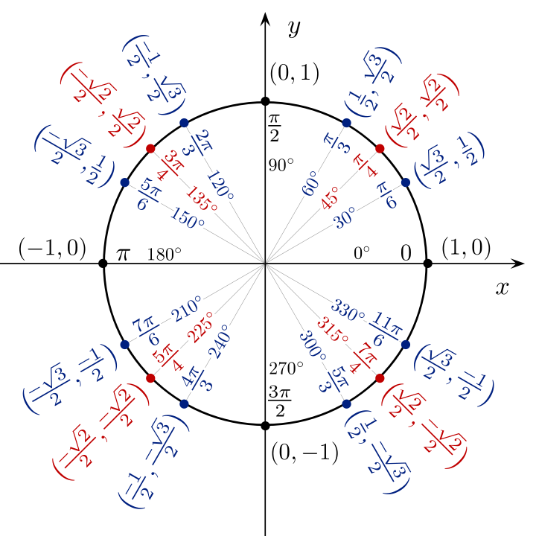

Remind the student that each point on the unit circle represents $(cosθ, sinθ)$ and we can write each point on the circle as a matrix.
Example: $\left(1,0\right)=\left[\begin{matrix}x \\ y\end{matrix}\right]=\left[\begin{matrix}1 \\ 0\end{matrix}\right]$

Rotation Matrix:

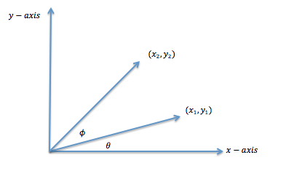
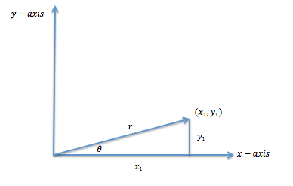
We have a vector, $<x_{1},y_{1}>$ or $\left[\begin{matrix}x_{1} \\ y_{1}\end{matrix}\right],$ with the length of $r$

$$cosθ=\frac{x_{1}}{r}$$  $$x_{1}=rcosθ$$ | $$sinθ=\frac{y_{1}}{r}$$  $$y_{1}=rsinθ$$

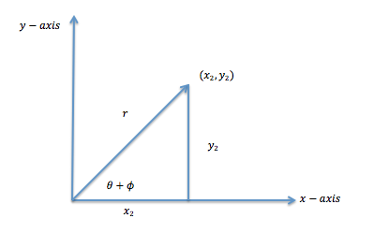

After rotation of $ϕ$, $r$ is the length of $<x_{2},y_{2}>$ or $\left[\begin{matrix}x_{2} \\ y_{2}\end{matrix}\right]$

$$x_{2}=rcos\left(θ+ϕ\right)$$  $$x_{2}=r\left(\cos{θ\cos{ϕ}}-\sin{θ}\sin{ϕ}\right)$$  $$x_{2}=r\cos{θ\cos{ϕ}}-r\sin{θ}\sin{ϕ}$$  $$x_{2}=x_{1}\cos{ϕ}-y_{1}\sin{ϕ}$$ | $$y_{2}=rsin\left(θ+ϕ\right)$$  $$y_{2}=r\left(\sin{θ\cos{ϕ}}+\cos{θ}\sin{ϕ}\right)$$  $$y_{2}=r\sin{θ\cos{ϕ}}+r\cos{θ}\sin{ϕ}$$  $$y_{2}=y_{1}\cos{ϕ}+x_{1}\sin{ϕ}$$  $$y_{2}=x_{1}\sin{ϕ}+y_{1} c\cos{ϕ}$$

$$\left[\begin{matrix}x_{2} \\ y_{2}\end{matrix}\right]=\left[\begin{matrix}x_{1}\cos{ϕ}-y_{1}\sin{ϕ} \\ x_{1}\sin{ϕ}+y_{1} cosϕ\end{matrix}\right]=\left[\begin{matrix}\cos{ϕ} & -sin{ϕ} \\ \sin{ϕ} & \cos{ϕ}\end{matrix}\right]\left[\begin{matrix}x_{1} \\ y_{1}\end{matrix}\right]$$

Rotation Matrix: $\left[\begin{matrix}\cos{ϕ} & -sin{ϕ} \\ \sin{ϕ} & \cos{ϕ}\end{matrix}\right]$

Great video resource for students: https://www.youtube.com/watch?v=OYuoPTRVzxY
Using the Rotation Matrix:

Using the point $\left(1, 0\right)$or $\left[\begin{matrix}1 \\ 0\end{matrix}\right]$, rotate the point $135°$

$$\left[\begin{matrix}x_{2} \\ y_{2}\end{matrix}\right]=\left[\begin{matrix}\cos\left(135\right) & -sin\left(135\right) \\ \sin\left(135\right) & \cos\left(135\right)\end{matrix}\right]\left[\begin{matrix}1 \\ 0\end{matrix}\right]$$

Using our unit circle we can see what each trig value is at $135°$

$$\left[\begin{matrix}x_{2} \\ y_{2}\end{matrix}\right]=\left[\begin{matrix}-\frac{\sqrt{2}}{2} & -\frac{\sqrt{2}}{2} \\ \frac{\sqrt{2}}{2} & -\frac{\sqrt{2}}{2}\end{matrix}\right]\left[\begin{matrix}1 \\ 0\end{matrix}\right]$$

Multiply the two matrices together to get $\left[\begin{matrix}x_{2} \\ y_{2}\end{matrix}\right]=\left[\begin{matrix}-\frac{\sqrt{2}}{2} \\ \frac{\sqrt{2}}{2}\end{matrix}\right]$

Reflection Matrix:

Using our rotation matrix, we will not use that to find a reflection matrix. When we compose a reflection with a rotation we get a rotation, this will be the key to finding a reflection matrix. We are going to multiply the rotation matrix by a reflection of the x-axis matrix multiplied by the inverse of the rotation matrix. First we need to find the inverse of the rotation matrix.

$$\left[\begin{matrix}\cos{ϕ} & -sin{ϕ} \\ \sin{ϕ} & \cos{ϕ}\end{matrix}\right]$$

$$det=\cos^{2}{ϕ+\sin^{2}{ϕ}=1}$$

$$\frac{1}{1}\left[\begin{matrix}\cos{ϕ} & \sin{ϕ} \\ -sin{ϕ} & \cos{ϕ}\end{matrix}\right]=\left[\begin{matrix}\cos{ϕ} & \sin{ϕ} \\ -sin{ϕ} & \cos{ϕ}\end{matrix}\right]$$

Set up the multiplication, the reflection over the x-axis changes sign on the y-axis, so the matrix would be described as: $\left[\begin{matrix}1 & 0 \\ 0 & -1\end{matrix}\right]$

$$\left[\begin{matrix}\cos{ϕ} & -sin{ϕ} \\ \sin{ϕ} & \cos{ϕ}\end{matrix}\right]\left[\begin{matrix}1 & 0 \\ 0 & -1\end{matrix}\right]\left[\begin{matrix}\cos{ϕ} & \sin{ϕ} \\ -sin{ϕ} & \cos{ϕ}\end{matrix}\right]$$

Multiply the x-axis reflection by the inverse of the rotation matrix:

$$\left[\begin{matrix}1 & 0 \\ 0 & -1\end{matrix}\right]\left[\begin{matrix}\cos{ϕ} & \sin{ϕ} \\ -sin{ϕ} & \cos{ϕ}\end{matrix}\right]=\left[\begin{matrix}\cos{ϕ} & \sin{ϕ} \\ \sin{ϕ} & -cos{ϕ}\end{matrix}\right]$$

Now multiply the rotation matrix by the result:

$$\left[\begin{matrix}\cos{ϕ} & -sin{ϕ} \\ \sin{ϕ} & \cos{ϕ}\end{matrix}\right]\left[\begin{matrix}\cos{ϕ} & \sin{ϕ} \\ \sin{ϕ} & -cos{ϕ}\end{matrix}\right]=\left[\begin{matrix}\cos^{2}{ϕ}-\sin^{2}{ϕ} & \cos{ϕ\sin{ϕ+\sin{ϕ\cos{ϕ}}}} \\ \sin{ϕ\cos{ϕ+\sin{ϕ\cos{ϕ}}}} & \sin^{2}{ϕ-\cos^{2}{ϕ}}\end{matrix}\right]$$

$$=\left[\begin{matrix}\cos{2ϕ} & 2\sin{ϕ\cos{ϕ}} \\ 2\sin{ϕ\cos{ϕ}} & -(\cos^{2}{ϕ}-\sin^{2}{ϕ})\end{matrix}\right]=\left[\begin{matrix}\cos{2ϕ} & \sin{2ϕ} \\ \sin{2ϕ} & -cos{2ϕ}\end{matrix}\right]$$

Reflection Matrix: $\left[\begin{matrix}\cos{2ϕ} & \sin{2ϕ} \\ \sin{2ϕ} & -cos{2ϕ}\end{matrix}\right]$
Using the Reflection Matrix:

Using the point $\left(1, 0\right)$or $\left[\begin{matrix}1 \\ 0\end{matrix}\right]$, rotate the point $\frac{3π}{4}$ (same as $135°)$

$$\left[\begin{matrix}x_{2} \\ y_{2}\end{matrix}\right]=\left[\begin{matrix}\cos\left(2*\frac{3π}{4} \right) & \sin\left(2*\frac{3π}{4} \right) \\ \sin\left(2*\frac{3π}{4} \right) & -cos\left(2*\frac{3π}{4} \right)\end{matrix}\right]\left[\begin{matrix}1 \\ 0\end{matrix}\right]$$

$$\left[\begin{matrix}x_{2} \\ y_{2}\end{matrix}\right]=\left[\begin{matrix}\cos\left(\frac{3π}{2} \right) & \sin\left(\frac{3π}{2} \right) \\ \sin\left(\frac{3π}{2} \right) & -cos\left(\frac{3π}{2} \right)\end{matrix}\right]\left[\begin{matrix}1 \\ 0\end{matrix}\right]$$

Using our unit circle we can see what each trig value is at $\frac{3π}{2}$

$$\left[\begin{matrix}x_{2} \\ y_{2}\end{matrix}\right]=\left[\begin{matrix}0 & -1 \\ -1 & 0\end{matrix}\right]\left[\begin{matrix}1 \\ 0\end{matrix}\right]$$

Multiply the two matrices together to get $\left[\begin{matrix}x_{2} \\ y_{2}\end{matrix}\right]=\left[\begin{matrix}0 \\ -1\end{matrix}\right]$

Activity:
- Choose a shape with 4 or more vertices (not a line or triangle) and draw in the first quadrant on exact points.
- Rotate 3 times, selecting a rotation from each quadrant.
- Reflect 3 times, selecting a reflection from each quadrant.

Example:
Rotation or $135°, 225°, 300°$ Reflection $135°, 225°, 330°$

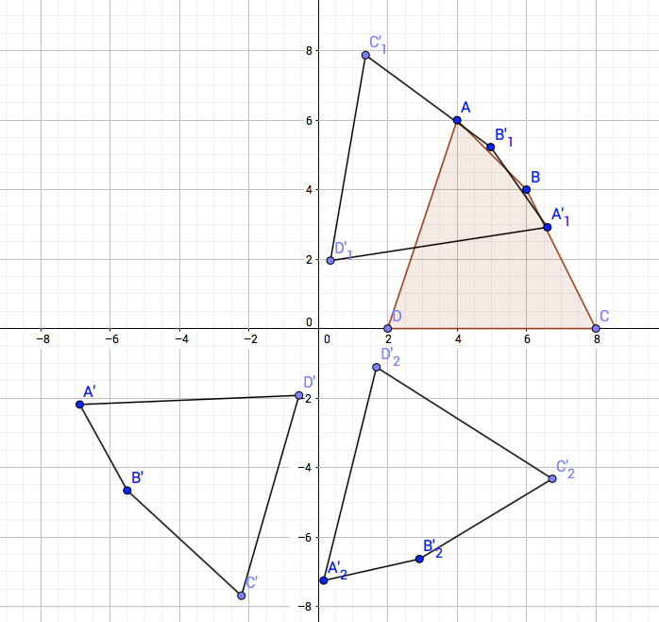
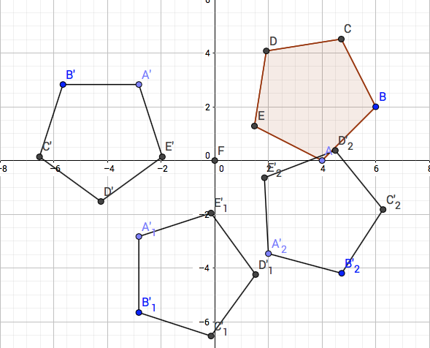

Discuss the difference between a rotation of $135°$ and a reflection of $135°$, what quadrant to the each end up in?

Compositions of Transformations:

Discuss what happens with each of the following and how do we know:

- Rotation and Rotation?
- Reflection and Rotation?
- Reflection and Reflection?

Rule for Compositions of Transformations:
$$G$$ | $$F$$ | $$G∘F$$
$$Rot_{b}$$ | $$Rot_{a}$$ | $$Rot_{a+b}$$
$$Ref_{b}$$ | $$Ref_{a}$$ | $$Rot_{2b-2a}$$
$$Ref_{a}$$ | $$Rot_{2b}$$ | $$Ref_{a-b}$$
$$Rot_{2b}$$ | $$Ref_{a}$$ | $$Ref_{a+b}$$

Practice:
Use the rules for compositions of transformations to find the one transformation:

- $rot_{\frac{π}{2}}∘rot_{π}=rot_{\frac{3π}{2}}$

- $ref_{\frac{π}{3}}∘ref_{\frac{2π}{3}}= rot_{2π} or rot_{0}$

- $ref_{\frac{2π}{3}}∘rot_{\frac{2π}{3}}=ref_{\frac{π}{3}}$

- $rot_{\frac{4π}{3}}∘ref_{\frac{π}{2}}=ref_{\frac{π}{6}}$

Homework:
For each of the following answer above, use $\left[\begin{matrix}-1 \\ 4\end{matrix}\right]$ and plug into either the reflection or the rotation matrix to get the composition transformation and graph.

