Wall Paper Groups

So what is a Wall Paper Group?

Wallpaper groups represent patterns that repeat themselves in two distinct directions (think about the x and y axis) with a specific rule. These patterns will cover the ENTIRE plane.

Some examples are:

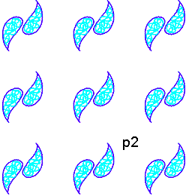
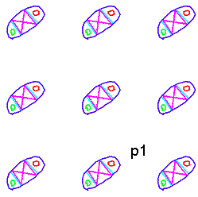

P1 is an example of ___________ only. P2 has two transformations. Which ones?

Why doesn’t this example have reflections? And this one?

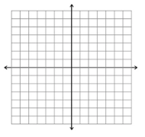
Wallpaper groups will only include rigid transformations. Why couldn’t we “wall paper” with dilations?

Turns out there are 17 possible wall paper groups

Possible rules are:
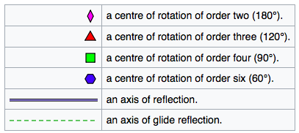

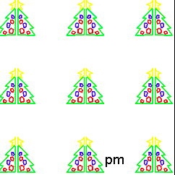
Some are simple:

P1: Just Translations

P2: Translations and 180 Rotation

PM: Translations and One Reflection

Some combine those ideas:

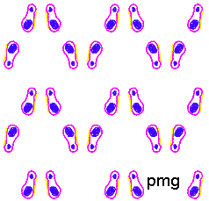
PMG: Translations, 180 Rotations, One way Reflection

Some are truly tricky!

P4M: Translations, two rotation centers of 90, reflections in four directions (horizontal, vertical, and both diagonals) It has additional glide reflections whose axes are not reflection axes
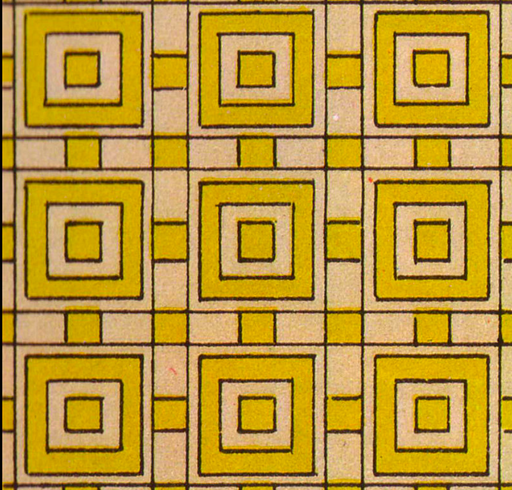
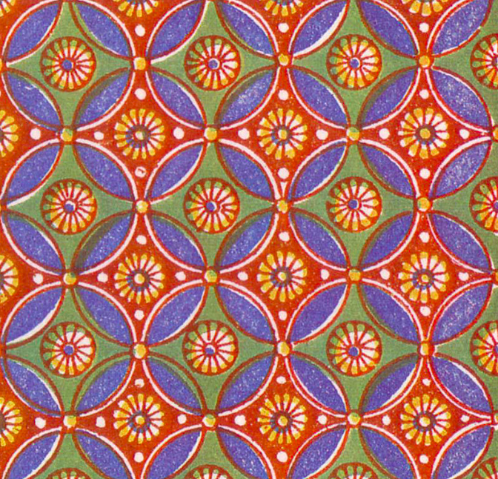
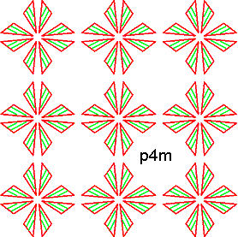
Name _____________________________________________ Date _____________ Period____________

A Mathematical Makeover!

In case you’ve never seen the show, let me catch you up. Chip and Joanna Gaines “buy the worst house in the best neighborhood” and renovate it for a family. Only this hypothetical time, the family is giving them the most cryptic feedback. They have decided to hire you as an expert to help make sense of this mathematical families unique taste.

Activity 1
Neighborhood Selection:

Chip and Joanna took the Gauss’s (our math family) to see several houses. Chip and Joanna could tell that they liked the two neighborhoods below best, but were unsure which house they chose based on their feedback. Read the note from the Gauss’s below, circle the neighborhood they chose, and explain why you think it is that house.

“We know which house we want! We decided on the house with the most rotational symmetry. It felt really important to us that the other houses be as close to a $60°$rotation away as possible. “

- Circle one

Neighborhood #1

Neighborhood #2

- Why do you think that is the neighborhood?

- Which wallpaper best match’s the Gauss’s description? Also, list at least one more symmetry it has.
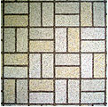
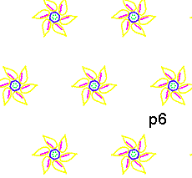

Activity 2:
Kitchen Backsplash Tile:

The remodel has started and now our family is picking out kitchen finishes. Read the note from the Gauss’s below, circle the tile they chose, and explain why you think it is the correct tile. (You could draw in the line of symmetry, hint hint)

“We LOVED the tile with only a vertical reflection, not the horizontal reflection. This tile will really accent the high ceilings.”

- Circle one

Tile choice #1 Tile choice #2
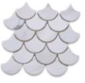

- Why do you think that is the tile they meant?

- What can you add to this design so that it has only vertical symmetry?

Activity 3:
Bathroom Tile

All this symmetry talk got Chip thinking about even more types of symmetry. He looked at the two tiles below and decided that they both have rotational symmetry of 90.

Tile choice #1 Tile choice #2
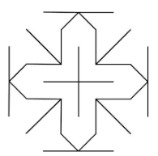

- Chip made a mistake! Explain what type of rotational symmetry each tile actually has.

- What type of symmetry is shown in the quilt below? (This quilt was added to the house for finishing touches.)
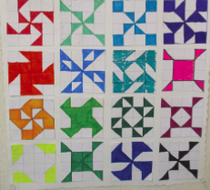

9. Draw you own quilt square with the same type of symmetry shown above. (DO NOT repeat one of the above patterns. Be original!)

