Lesson Plan
This lesson is geared towards Secondary Math 1 students.

Standards Addressed:
Strand: GEOMETRY - Congruence (G.CO)
Experiment with transformations in the plane. Build on student experience with rigid motions from earlier grades (Standards G.CO.1–5). Understand congruence in terms of rigid motions. Rigid motions are at the foundation of the definition of congruence. Reason from the basic properties of rigid motions (that they preserve distance and angle), which are assumed without proof. Rigid motions and their assumed properties can be used to establish the usual triangle congruence criteria, which can then be used to prove other theorems (Standards G.CO.6–8). Make geometric constructions (Standards G.CO.12–13).

Standard G.CO.3
Given a rectangle, parallelogram, trapezoid, or regular polygon, describe the rotations and reflections that carry it onto itself.

Standard G.CO.4
Develop definitions of rotations, reflections, and translations in terms of angles, circles, perpendicular lines, parallel lines, and line segments

Note: This lesson is a supplement to a lesson more focused on the shapes mentioned in Standard G.CO.3. Be sure to cover those as well.

Goal of the lesson:

- To identify the order and the angles for the symmetry
- To distinguish between rotations and reflections
- To use the n notation in another setting

Things the students should know prior to this lesson:
- They should have been introduced to rotational symmetry, ie how many degree until a figure maps onto itself
- They should have seen reflections and rotations previously (the 8th grade coverage of this is plenty)
- Defined the word isometry

Things to stress
- How the order relates to the degrees needed for rotational symmetry
- How many more symmetries the Dihedral groups will have
- Spotting the difference between pure rotation and reflection with rotation will be helpful for composition of transformations later in this unit.

There are two options for homework. The first homework asks harder questions and leaves room for creativity, a good challenge. The second homework is a great remediation piece. It strips the concept down to the basics. Use what’s best for your situation.

Rosettes Notes
A rosette pattern is a pattern that has either of the following types of symmetry:

Cyclic Symmetry: rotation symmetry around a center point, but no mirror lines

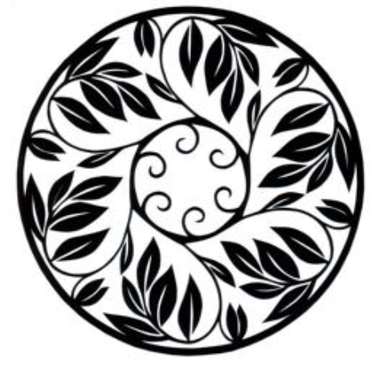

Dihedral Symmetry: rotation symmetry around a center point with mirror lines through the center point.

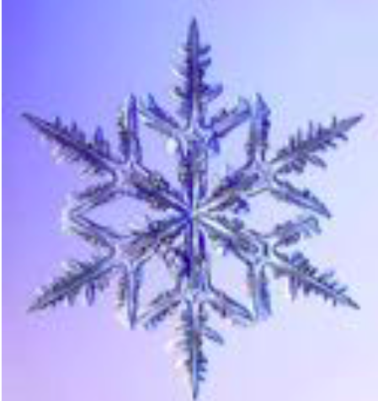

This type of rosette is referred to as D_{n}.

D_{n} means that there are ______________ mirrors meeting at the center, and the (largest) order of rotation is ___________
This type of rosette is referred to as C_{n.}

The does the “n” mean in C_{n}?

C_{n} means that the smallest angle of rotation that preserves the figure has ____ degrees. This rotation has order_____

Example 1.
What type of symmetry does it have?

For a figure with C₅ symmetry, how many distinct isometries preserve the figure? Include the “do nothing” isometry, called the identity isometry,

Example 2:
What type of symmetry does it have?

For figures with_______ symmetry, how many distinct rotations preserve the figure?

How many distinct reflections preserve the figure?

In total, how many distinct isometries preserve the figure?
Rosettes Notes Continued
Fundamental Domains

A fundamental domain for a symmetry pattern is a piece (of the smallest possible are) that can be represented by isometries to generate the entire pattern.

Example 3:

Ambigrams:

Today Ambigrams are used in graphic design, commercial logos, book covers, tattoo artworks and music albums.

An ambigram (from Latin: ambi both + gram letter) is a word or words that can be read in more than one direction, where the word reads the same when upside down or turn over to form and entirely new word.

These are possible because of their different symmetries!

Some Examples:

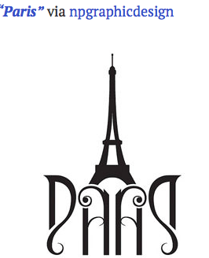

Name ___________________________________________ Date______________ Period_____________

More on Rotational Symmetry
Identify and Classify Rosette Patterns

Fill in the table below for each of the nine rosettes.

 | Type of Symmetry | List ALL the distinct isometries that preserve the figure | Draw the fundamental domain for the figure
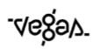
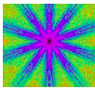
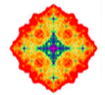

Ambigram Practice
 | What is the word? | What type of symmetry?
1.
2.
3.
4.
5.
6.
7.
8.

Ambigram Practice
Each design on this page is really half of a word. Can you figure out what each design says? To read a design, take two copies of this page, place one copy on top of the other, and slide them around until the two copies of the design meet. Hold the papers up to a light so you can see through both sheets. You may have to rotate or flip over one of the pages. For instance, the second design makes the word ”mirror”. (Scott Kim, 2000)
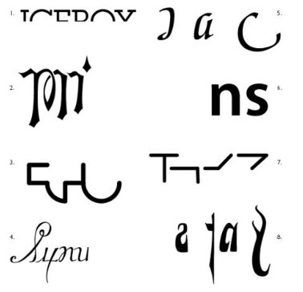

Name ________________________________________ Date___________ Period _________

More on Rotational Symmetry HW

Group the letters of the alphabet according to their symmetry types using C_{n} and D_{n} notation:

A B C D E F G H I J K L M N O P Q R S T U V W X Y Z

Name ________________________________________ Date___________ Period _________

More on Rotational Symmetry HW

Group the letters of the alphabet according to their symmetry types using C_{n} and D_{n} notation:

A B C D E F G H I J K L M N O P Q R S T U V W X Y Z

2. As a child, you ay have made snowflake patterns by folding a piece of paper and cutting along the edges. Make snowflakes representing at least three of these symmetry groups: D₂, D₃, D₄, D₅, D₆, and D_{8.} Be sure to label each snowflake with the symmetry group!

(Each snowflake will be on a separate paper that we will staple and turn in with this half sheet)

Challenge: Can you make a C₂ snowflake? (hint: you can use tape)

2. As a child, you ay have made snowflake patterns by folding a piece of paper and cutting along the edges. Make snowflakes representing at least three of these symmetry groups: D₂, D₃, D₄, D₅, D₆, and D_{8.} Be sure to label each snowflake with the symmetry group!

(Each snowflake will be on a separate paper that we will staple and turn in with this half sheet)

Challenge: Can you make a C₂ snowflake? (hint: you can use tape)

Name ________________________________________ Date___________ Period _________

More on Rotational Symmetry HW

- Classify the following figures as either cyclic or dihedral and by the number of symmetries.
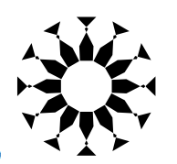

- Hubcaps (wheel covers) are often either cyclic or dihedral figures. Classify the following:

- For each of the following, create the indicated figure from the initial pattern shown:

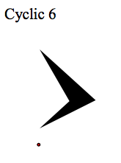
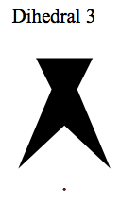

Almost word for word, the notes and activity was taken from:

http://lindagreen.web.unc.edu/files/2015/12/Math53_Part8_Rosettes.pdf

fantastic resource!

Some additional examples were taken from

http://www.hongkiat.com/blog/creative-and-cool-ambigram-designs/

The last alternative homework is from a resource from