Math 1050 ~ College Algebra

7 Graphs of Polynomials

A Polynomial Function and Vocabulary
$f(x)=a_{n}x^{n}+a_{n-1}x^{n-1}+a_{n-2}x^{n-2}+…+a_{l}x+a_{0}$.
Degree

Leading Term

Leading coefficient

Constant

EX 1
Determine which of these are polynomial functions and identify the degree, the leading term, the leading coefficient and the constant of those that are.

1a)
$f(x)=\sqrt{5}x^{2}-4x^{3}$

1b)
$f(x)=\sqrt[3]{x+2}+1$

1c)
$f(x)=-3(x-2)^{2}+4x^{6}$

1d)
$f(x)=\frac{x-3}{x+2}$

1e)
$f(x)=\frac{6x^{5}+3x^{2}-1}{3}$

1f)
$f(x)=π$

Polynomial functions have the characteristic of being continuous and smooth.
The leading coefficient and the degree can tell us a lot about the graph of a polynomial, including its end behavior.
$n$ is odd, $a>0$ $n$ is even, $a<0$

$n$ is even, $a>0$ $n$ is odd, $a<0$

EX 2
For each graph, guess at a likely degree, circle the $x$ and $y$-intercepts, and identify the sign ( + or -) of the leading coefficient.
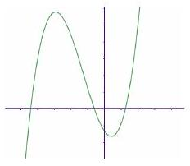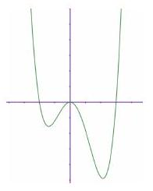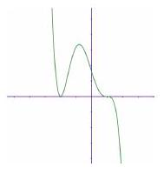
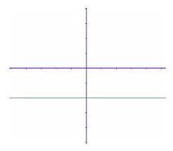
To graph a polynomial, it helps to determine the roots and the y-intercept.

Real Zeros of Polynomial Functions
Equivalent Statements: for $a∈R,f(x)$ a polynomial
- $x=a$ is a zero of $f(x)$.
- $x=a$ is a solution of $f(x)=0$.
- ( $x-a$ ) is a factor of $f(x)$.
- $(a,0)$ is an $x$-intercept of the graph of $f(x)$.

Repeated Zeros
A factor $(x-a)^{k}$ for $k>1$ yields a repeated zero, $x=a$ of multiplicity $k$.
- If $k$ is odd, the graph crosses the $x$-axis at $x=a$.
- If $k$ is even, the graph touches the $x$-axis at $x=a$.

Intermediate Value Theorem
Let $a,b∈R$ and $a<b$. If $f(x)$ is a polynomial and $f(x)≠f(b)$, then over the interval $[a,b],f$ takes on every value between $f(a)$ and $f(b)$.

EX 3
For each function, describe the end-behavior, find all real zeros, including multiplicity, and the number of turning points on the graph.

3a)
$f(x)=(x+2)^{2}(x-1)^{3}$

3b)
$f(x)=-x(x+7)(x-3)^{2}$

EX 4
Sketch the graph of $f(x)$ by looking at the leading coefficients, finding the zeros, and perhaps plotting more points.
$$f(x)=-48x^{2}+3x^{4}$$
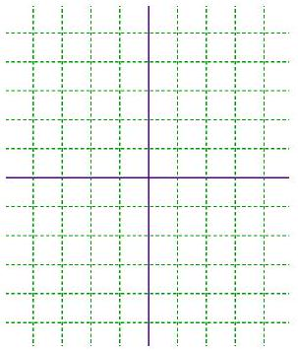

An Application Problem

EX 5
The profit (in millions of dollars) for a sport cap manufacturer can be modeled by $P(x)=-x^{3}+4x^{2}+x$, where $x$ is the number of caps they produce (in millions). They currently produce 4 million caps, making a profit of $\$4,000,000$. What smaller number of caps could they make and still make the same profit?

