Math 1050 ~ College Algebra

6 Quadratic Functions
- Graph a quadratic function through transformations of $f(x)=x^{2}$.
- Change a quadratic function from general to standard form.
- Find the vertex and axis of symmetry of a quadratic function.
- Find the intercepts of a quadratic function.
- Graph a quadratic function using vertex, axis of symmetry and

Quadratic Functions
A polynomial function: $f(x)=a_{n}x^{n}+a_{n-1}x^{n-1}+a_{n-2}x^{n-2}+…+a_{l}x+a_{0}$.

A quadratic function is a type of polynomial function where the degree $=2$.
$$f(x)=ax^{2}+bx+c a,b,c∈R,a≠0$$
general form | standard form
$$f(x)=ax^{2}+bx+c$$ | $$f(x)=a(x-h)^{2}+k$$

axis of symmetry  vertex  concavity | 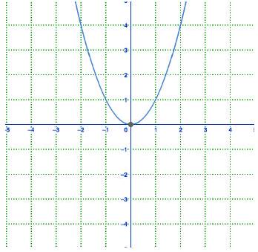

EX 1
Determine the vertex, axis of symmetry and concavity of each of these.

1a)
$f(x)=3x^{2}+6x-4$

1b)
$f(x)=-2(x+3)^{2}-4$

EX 2
Write the equation of this quadratic function in standard form, then use algebra to write it in general form.
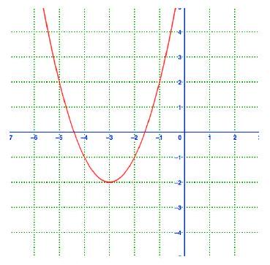

EX 3
Put this equation in standard form and sketch a graph of it.
$$y=-2x^{2}+4x+2$$
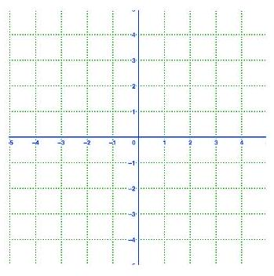

Finding Roots of Quadratic Functions
To find the roots, solve for $f(x)=0$.
If the expression on the left factors, set each factor equal to 0 and solve for $x$.
If you prefer not to factor, or it does not factor, you can always use the Quadratic Formula.
Quadratic Formula $ax^{2}+bx+c=0⇒x=\frac{-b±\sqrt{b^{2}-4ac}}{2a}$

EX 4
Determine the roots of each of these.

4a)
$f(x)=3x^{2}+5x-4$

4b)
$f(x)=9x^{2}-6x+1$

4c)
$f(x)=4x^{2}-6x-3$

In the quadratic formula, the expression inside the radical is called the discriminant. It determines whether there is one real root, two real roots or no real roots.

EX 5
Find the discriminant of the equations in example 4.

5a)
$f(x)=3x^{2}+5x-4$

5b)
$f(x)=9x^{2}-6x+1$

5c)
$f(x)=4x^{2}-6x-3$

EX 6
For this function, find the vertex, axis of symmetry, $x$ and $y$-intercepts and sketch it.
$$f(x)=-\frac{1}{2}\left(x^{2}-10x+21\right)$$
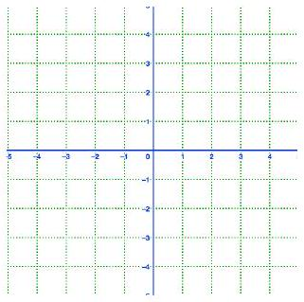

An Application Problem

EX 7
The height of an object shot straight up in the air from a height of 128 feet at an initial velocity of $32ft/sec$ is modeled by $h(t)=-16t^{2}+32t+128$, where $t=$ time.
Determine the maximum height the object reaches and the time it will hit the ground.

