Math 1050 ~ College Algebra
6.5 Supplemental Video

Completing the Square
For a good explanation of how to complete the square, see
http://www.mathsisfun.com/algebra/completing-square.html
This is useful in solving a quadratic equation and in putting that equation in standard form.

EX 1
Solve by completing the square.

1a)
$$x^{2}-6x-3=0$$

1b)
$$3x^{2}-6x-9=0$$

1c)
$$2x^{2}-5x+4=0$$

EX 2
Put these equations in standard form. $y=a(x-h)^{2}+k$

2a)
$$y=x^{2}+2x-2$$

2b)
$$y=2x^{2}-4x-3$$

2c)
$$y=-1/2x^{2}-3x+5$$

Deriving the Quadratic Formula
If $ax^{2}+bx+c=0,a≠0$, then $x=\frac{-b±\sqrt{b^{2}-4ac}}{2a}$.

EX 3
Solve this equation for $x$, if $a,b$ and $c$ are constants.
$$ax^{2}+bx+c=0$$

Deriving the Formula for the Vertex
The vertex of $f(x)=ax^{2}+bx+c$ is at the point $\left(-\frac{b}{2a},f\left(-\frac{b}{2a}\right)\right)$.
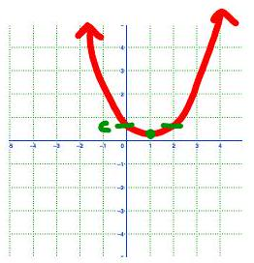

EX 4
Determine the vertex for each of these using the above method.

4a)
$$y=x^{2}+2x-2$$

4b)
$$y=2x^{2}-6x-3$$

4c)
$$y=-1/2x^{2}-3x+5$$

