Math 1050 ~ College Algebra

5 Inverses of Functions

Inverse Function
If $f$ and $g$ are functions such that
- $(f∘g)(x)=x$ for all $x$ in the domain of $g$
- $(g∘f)(x)=x$ for all $x$ in the domain of $f$
then $f$ and $g$ are inverses of each other.
This is written $f^{-1}(x)=g(x)$ and $g^{-1}(x)=f(x)$.

To have an inverse, a function must be one-to-one, that is for each output there must be exactly one input.
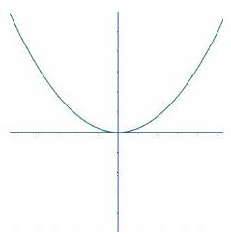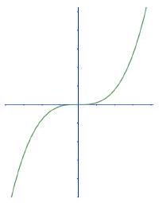

Finding an Inverse Function

Strategy

EX 1
For $f(x)$, find the inverse function, $f^{-1}(x)$.
1a) $f(x)=\frac{x^{5}-1}{3}$ 1b) $f(x)=\sqrt[3]{x+2}+1$

Graphical Properties of Inverse Functions
Assume $f$ and $g$ are inverse functions.
- The domain of $f$ is the range of $g$ and the domain of $g$ is the range of $f$.
- $f(a)=b$ if and only if $g(b)=a$.
- ( $a,b$ ) is on the graph of $f$ if and only if ( $b,a$ ) is on the graph of $g$.
- $f$ and $g$ are symmetric about the line $y=x$.
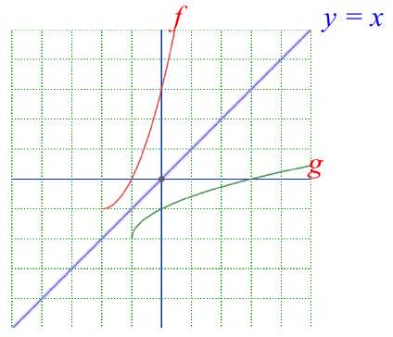

EX 2
Sketch the inverse, $f^{-1}$, of $f$ on the same axes. State the domain and range of each.
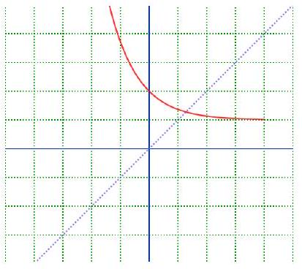

EX 3
Show that these two functions are inverses in two ways.
$$g(x)=\frac{1-x}{x}, 0<x≤1 f(x)=\frac{1}{1+x}, x≥0$$

3a)
Algebraically

3b)
Graphically
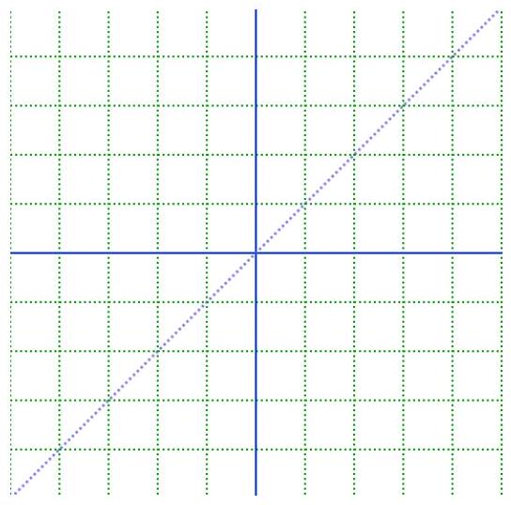

EX 4
Find the inverse of $f(x)=\frac{x-3}{x+2}$.

