Math 1050 ~ College Algebra

3 Transformations of Functions

Transformations of Functions
Types of transformations from y = f(x) to y = Af(Bx - C) + D

Shifts
Vertical: h(x) = f(x) + D Example: $y=x^{2}+2$
Horizontal: g(x) = f(x-C) Example: $y={\left(x-1\right)}^{3}$

Reflect
Vertical: h(x) = -(f(x)) Example: $y=-x^{2}$
Horizontal: g(x) = f(-x) Example: $y=\sqrt{-x}$

Stretch/shrink
Vertical: h(x) = A(f(x)) Example: $y=5x^{3}$
Horizontal: g(x) = f(Bx) Example: $y=\sqrt{\left(1/2\right)x}$

EX 1
Graph these functions.

1a)
$$y=-\sqrt{\left(-x\right)}$$
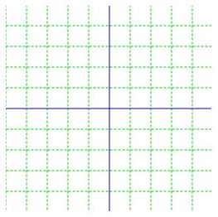

1b)
$$y=|x-2|+1$$
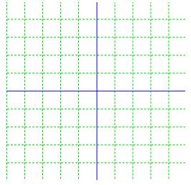

1c)
$$y=-x^{2}+3$$
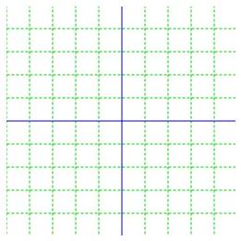

1d)
$$y=\frac{1}{2}{\left(x+1\right)}^{3}-3$$
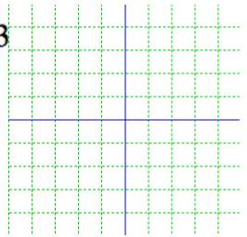

EX 2
Write an equation for each of these graphs.

2a)
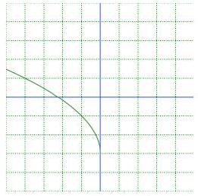

2b)
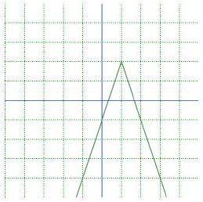

EX 3
Given this graph for $f(x)$, sketch the graphs of the transformed functions.
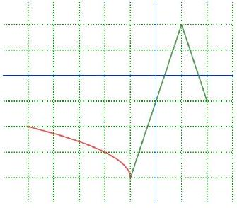

3a)
$$f(-x)$$
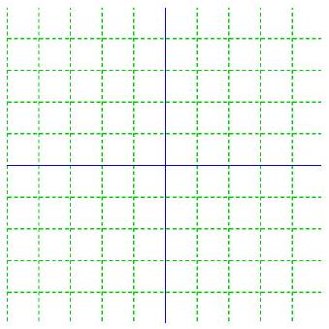

3b)
$$f(x-1)+3$$

3c)
$$-2f(x)$$

EX 4
Describe transformations compared to the base toolkit graph for each of these.

4a)
$$f(x)=2(x+1)^{3}-9$$

4b)
$$f\left(x\right)=-2\sqrt{x+1}+3$$

It may be helpful to use the table method to sketch a graph with several transformations. Let's look at a way to sketch this function.
$$f\left(x\right)={\left(-\frac{1}{2}x-1\right)}^{3}+3$$

EX 5
Use the table method above to sketch this function.
$$f(x)=-3(x-2)^{2}+4$$
