Math 1050 ~ College Algebra

2 Graphs of Functions
Here is an example of a piece-wise function:

EX 1
In a small community, to encourage water-wise behavior, the water company has priced it so that consumers who use more water will pay more beyond some minimum usage. After being connected to the system, the residential consumer pays a monthly flat fee of $\$20$ until the usage exceeds 60 units. They will then pay $\$1.50$ for each unit exceeding 60 up to 120 units, after which they will pay $\$3.00$ per unit for those units over 120.
This is a graph of the function. Here is what that function looks like, where $C(u)$ is the cost of your water in dollars and $u$ is a unit of water (10,000 gallons).
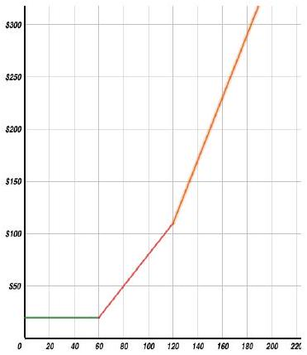 | $$C(u)=\left\{\begin{matrix}20 & \text{for} & [0,60] \\ 1.5u-70 & \text{for} & (60,120] \\ 3u-270 & \text{for} & (120,∞)\end{matrix}\right.$$

Verify these by using the equation and the graph.
- $C\left(80\right)=$
- $C(-5)=$
- Why is $C(0)=20$ ?

The Toolkit Functions
There are several families of functions one needs to have in their toolkit.

Constant Function
f(x) = c
Domain:
Range:
x-intercept:
y-intercept:
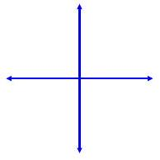

Identity Function
f(x) = x
Domain:
Range:
x-intercept:
y-intercept:

Absolute Value Function
f(x) = |x|
Domain:
Range:
x-intercept:
y-intercept:

Quadratic Function
f(x) = x^2
Domain:
Range:
x-intercept:
y-intercept:
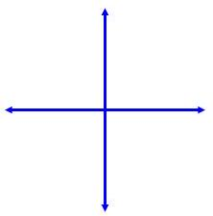

Square Root Function
f(x) = √x
Domain:
Range:
x-intercept:
y-intercept:
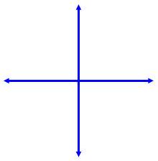

Cubic Function
f(x) = x^3
Domain:
Range:
x-intercept:
y-intercept:
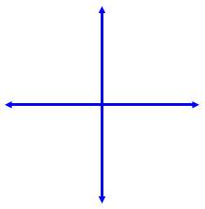

Cube Root Function
f(x) = ∛x
Domain:
Range:
x-intercept:
y-intercept:

Reciprocal Function
f(x) = 1/x
Domain:
Range:
x-intercept:
y-intercept:

Reciprocal Squared Function
f(x) = 1/x^2
Domain:
Range:
x-intercept:
y-intercept:

EX 2
Graph this piece-wise function.
$$f\left(x\right)=\left\{\begin{matrix}x^{2} & \text{if} & x ≤1 \\ -2 & \text{if} & 1 < x < 2 \\ x & \text{if} & x ≥ 2\end{matrix}\right.$$
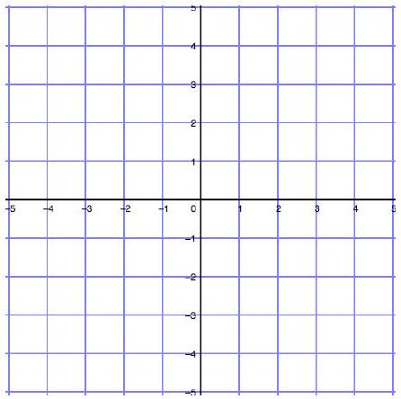

Where is a function increasing, decreasing or constant?

EX 3
Use the function, $f(x)$ from example 2 for this exercise.

3a)
Use points to describe where the function is increasing, decreasing or constant.

3b)

Use domain values to describe these behaviors.
Determining Maximum and Minimum Function Values

Relative minimum | Relative maximum
Absolute minimum | Absolute maximum

EX 4
Determine extrema values for this function.
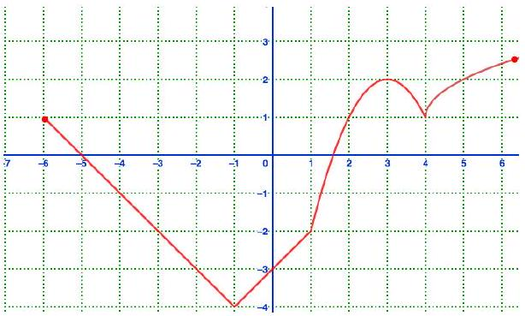

Symmetry of Functions
Even Functions Odd Functions

EX 5
Look at the toolkit functions and determine if any are even or odd as graphed earlier in this lesson.
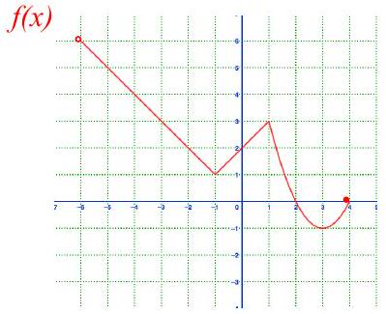

EX 6
Use the function $f(x)$, represented in this graph to analyze these characteristics.

6a)
domain of $f$

6b)
range of $f$

6c)
x-intercept(s) of $f$

6d)
y-intercept of $f$

6e)
zeros (roots) of $f$

6f)
solve $f(x)=2$

6g)

$$f(3)=$$

6h)
interval(s) of increase

6i)
maximum/minimum values

6j)
symmetry

