Math 1050 ~ College Algebra

21 Systems of Linear and Non-Linear Equations
- Solve systems of two linear equations in two variables using
series substitution.
- Solve systems of two linear equations in two variables using elimination.
to $2×2$ systems of linear e
- Solve systems of two non-linear equations in two variables using elimination.
- Solve systems of two non-linear equations in two variables using

A system of equations is simply more than one equation with two or more variables that we solve simultaneously.
If the two equations are linear, then one of three results is possible.

Solving Strategies
- Graph
- Substitution
- Elimination
- Other methods

EX 1
Solve using substitution.

1a)
$$x-y=-4 \\ x+2y=5$$

1b)
$$3x+y=2 \\ x^{3}-2+y=0$$

EX 2
Solve by graphing, then by substitution.
$$\begin{matrix}2x-y+3=0 \\ x^{2}+y^{2}-4x=0\end{matrix}$$
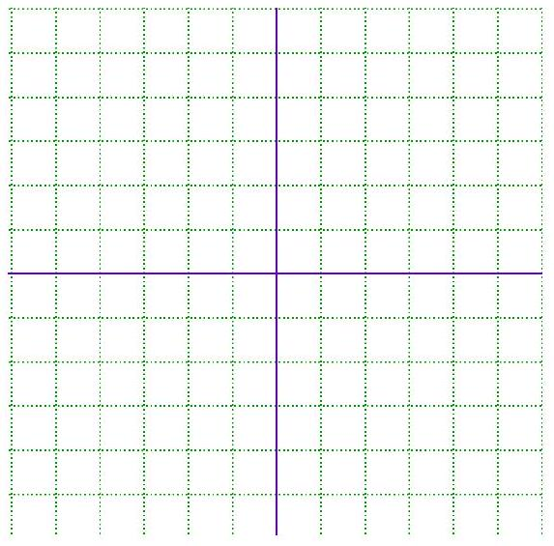

EX 3
Solve by Elimination.

3a)
$$3x-2y=7 \\ 8x+4y=0$$

3b)
$$x^{2}+3y=6 \\ y^{2}-x^{2}=4$$

EX 4
Solve algebraically by a method of your choice.

4a)
$$5x-3y=-2$$
$$3x+5y=9$$

4b)
$$3y=4x-5$$
$$-8x+6y=1$$

4c)
$$9x-3y=-15 \\ -3x+y=5$$

Application

EX 5
Two planes start from LAX and fly in opposite directions. The second plane starts a half-hour after the first plane, but its speed is 80 kph faster. Find the airspeed of each plane if 2 hours after the first plane departs the planes are 3200 km apart.

