Math 1050 ~ College Algebra

1 Introduction to Functions
A relation is a set of ordered pairs. The set of first components of the ordered pairs is called the domain and the set of second components of the ordered pairs is called the range.
input value

independent variable

output value

dependent variable

EX 1
For each of these, state whether it is a relation, and if it is, list the elements in the domain and in the range.

1a)
$\{(1,5),(5,-2),(5,4),(3,2)\}$

1b)
Bud | 15
May | 16
Ezi | 17
Zhu | 18
Tia | 19

1c)
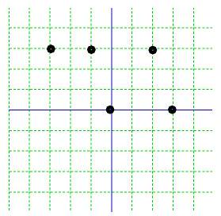

1d)
Input values: days of the week
Output values: final letter in word

1e)
{name, rank, serial number}

A function is a relation in which any two ordered pairs with the same first component also have the same second component.

EX 2
From example 1, which of the relations are functions?

2a)
$\{(1,5),(5,-2),(5,4),(3,2)\}$

2b)
Bud | 15
May | 16
Ezi | 17
Zhu | 18
Tia | 19

2c)
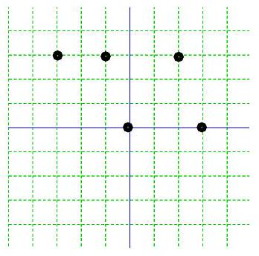

2d)
Input values: days of the week Output values: final letter in word

An equation in two variables can be a relation as can a 2-dimensional graph.

EX 3
Which of these are functions?

3a)
$x+3=y^{2}$

3b)
$2y=\sqrt{x-1}$

3c)
$x^{2}+y^{2}=9$

3d)
$\{(3,1),(2,1),(5,1),(6,2)\}$

The Vertical Line Test: A graph represents a function if no vertical line intersects it at more than one point.

EX 4
Use the vertical line test to determine if these relations are functions.
$$R_{1}=\{(1,5),(5,-2),(5,4),(3,2)\}$$
$$R_{2}=\{(3,1),(2,1),(5,1),(-3,2)\}$$
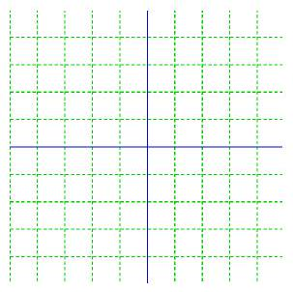

$$R_{3}$$
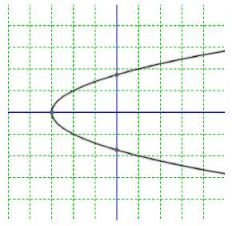
$$R_{4}$$
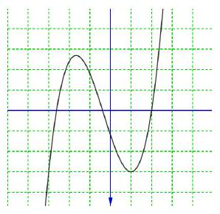

Function Notation
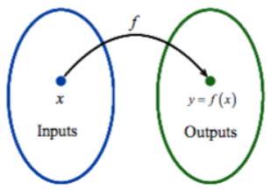

EX 5
Evaluate these functions for the given values.

5a)
$f(x)=\sqrt{x+8}+2$

$$f(-8)$$

$$f(x-8)$$

$$f(a)$$

5b)
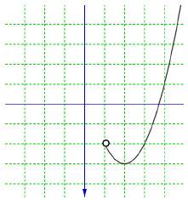
$g(2)=$

$$g(0)=$$

$$g(a)=-2 \text{for} a=$$

Domain of Functions
The domain of a function is the set of all input values for which the function is defined.
Implicit domain Explicit domain

EX 6
Determine the domain for each of these functions and identify as implicit or explicit.

6a)
$f(x)=\sqrt[3]{x+4}$

6b)
$p(x)$

6c)
$g(x)=\frac{3}{x^{2}-2x}$

6d)
$f(x)=\frac{\sqrt{x+4}}{4+x}$

6e)
$h(x)=5x-3, x>-1$

