Math 1050 ~ College Algebra

19 Logarithmic Equations and Functions

Determine the Domain of a Logarithmic Function
Remember $log⁡x$ is only defined for $x>0$.

EX 1
Determine the domain of each of these.

1a)
$f(x)=\log_{5}⁡(x+3)$

1b)
$g(x)=log⁡\left(x^{2}+3\right)$

1c)
$h(x)=ln⁡x-ln⁡(x+1)$

Solving Logarithmic Equations

EX 2
We will solve this equation by going through the basic steps.
$$log⁡(5x)+log⁡(x-1)=2$$
- Use properties of logs to condense logs into a single log expression on one side of the equation.

- Exponentiate both sides with the base matching the base of the log.

- Rewrite as an equivalent exponential equation.

- Solve and check.

EX 3
Graph this logarithmic function by following these steps. $f(x)=ln⁡|x+1|$

3a)
Determine the domain.

3b)
Find the $x$-and $y$-intercepts.

3c)
Determine any asymptotes.

3d)
Plot a few points and sketch the curve.
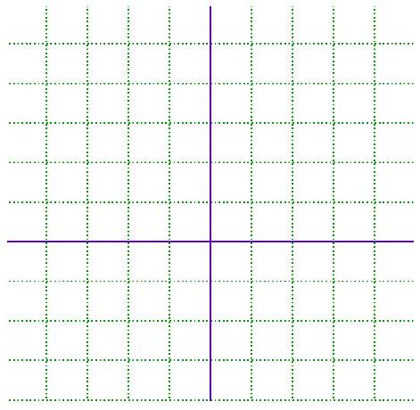

EX 4
Solve for $x$.

4a)
$\log_{3}⁡x-\log_{3}⁡(x+1)=2$

4b)
$ln⁡(x+4)-ln⁡(x-2)=ln⁡x$

EX 5
Marilyn is saving for her retirement by depositing $\$500$ per month into an account earning $5.4\%$ annual interest compounded monthly. The time it takes for such an account to grow to be worth $S$ dollars is given by this equation.
$$t=\frac{1}{12}\log_{\left(1+\frac{r}{12}\right)}⁡\left[\frac{Sr}{12P}+1\right]$$

$$\begin{matrix} & r= \text{annual interest rate} \\ t & = \text{time (in years)} \\ & P= \text{monthly payments} \end{matrix}$$
How many years will she need to keep making these monthly deposits for the account to be worth two million dollars?

