Math 1050 ~ College Algebra

18 Exponential Equations and Functions

Strategy for Solving Exponential Equations
- If you can get an exponential equation in the form of $b^{n}=b^{m}$, then you may use the one-to-one property, and $n=m$.

EX 1
Solve for $x$.

1a)
$3^{2x}=27$

1b)
$5^{x-1}={125}^{x+1}$

1c)
$$\left(\frac{1}{4}\right)2^{3x-1}=4^{x-2}$$
- Move the terms around to isolate the exponential on one side of the equation. Rewrite as an equivalent log equation, or take the log of both sides of the equation.

EX 2
Solve for $t$.

2a)
$3^{2t}=84$

2b)
$2\left(3^{2t-1}\right)-5=11$

2c)
$5e^{t-1}=9$
- If there is an exponential term on both sides of the equation, you need to take the $log$ of both sides.

EX 3
Solve for $t{.5}^{1-t}={12}^{t}$

Graphing an Exponential Function

EX 4
Sketch this function by following these steps. $f(x)=e^{\left(1-x^{2}\right)}$

4a)
Determine the domain.

4b)
Find the $x$-and $y$-intercepts.
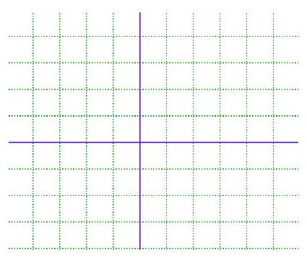

4c)
Sketch any horizontal or vertical asymptotes

4d)
Identify a few other points.

Application of Exponential Functions

EX 5
A certain bacteria exhibits a growth according to this equation, $P=2000e^{2.5t}$ where $P$ is the number present after $t$ hours and the initial number is 2000.

5a)
How long does it take the population to double?

5b)
When will the population reach 10,000?

