Math 1050 ~ College Algebra

17 Properties of Logarithms

Common and Natural Logarithms
Base 10 is commonly used in logarithms. Thus, when no base is indicated, it is assumed to be base 10.
$$log⁡x=\log_{10}⁡x$$

EX 1
Evaluate these.

1a)
$$log⁡1,000,000$$

1b)
$$log⁡\left({10}^{-3}\right)$$

1c)
$$log⁡0.01$$

1d)
$log$ (a trillion)

Another base is the irrational number, $e$, called the natural base. This is written using $ln⁡x$.
$$\log_{e}⁡x=ln⁡x$$

EX 2
Evaluate these.

2a)
$$ln⁡e$$

2b)
$$ln⁡e^{-3}$$

2c)
$$ln⁡e^{8}$$

2d)
$$ln⁡\left(\frac{1}{e^{5}}\right)$$

Natural Exponential Base
$$e≈2.718281828459….$$

EX 4
Sketch a graph of $y=e^{x}$.
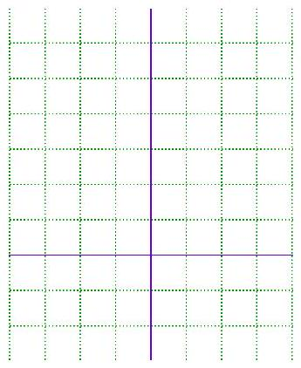
The exponential base is used in financial and scientific calculations which we will explore in a later chapter.

Logarithm Properties
Let $b$ be a positive number, not equal to 1, and let $x$ be a positive number.
$$\begin{matrix}\log_{b}⁡1=0 \\ \log_{b}⁡b=1 \\ \log_{b}⁡b^{x}=x \\ \text{If} \log_{b}⁡x=\log_{b}⁡y, \text{then} x=y\end{matrix}$$

EX 5
Evaluate these.

5a)
$ln⁡1$

5b)
$log⁡100$

5c)
$ln⁡e^{π}$

5d)
$log⁡\left({10}^{0.2}\right)$

EX 6
Determine the value of $x$ for each of these.

6a)
$log⁡x=log⁡(y+5)$

6b)
$ln⁡x=ln⁡(π+1)$

Properties of Logarithms

Change of Base Property
Let $a$ and $b$ be positive numbers, not equal to 1, and let $x$ be a positive number.
$$\log_{b}⁡x=\frac{\log_{a}⁡x}{\log_{a}⁡b}$$

EX 7
True or false? $\log_{2}⁡3=\frac{log⁡3}{log⁡2}$

EX 8
Use your calculator to give an approximate value for these.

8a)
$\log_{2}⁡5$

8b)
$log⁡50$

8c)
$ln⁡8$

8d)
$\log_{6}⁡0.0002$

Inverse Properties
Let $b$ be a positive number, not equal to 1.
$$\begin{matrix}b^{\log_{b}⁡x}=x, \text{for any positive number} x \\ \log_{b}⁡b^{x}=x, \text{for any real number} x\end{matrix}$$

EX 9
Use the inverse properties to simplify.

9a)
$ln⁡e-2$

9b)
$\log_{5}⁡1$

9c)
$6^{\log_{6}⁡20}$

9d)
$\log_{3}⁡3^{10}$

Exponent, Sum and Difference Properties of Logarithms
Let $b$ be a positive number, not equal to 1, and let $u$ and $v$ be positive numbers.
$$\begin{matrix}\log_{b}⁡(uv)=\log_{b}⁡u+\log_{b}⁡v \\ \log_{b}⁡\left(\frac{u}{v}\right)=\log_{b}⁡u-\log_{b}⁡v \\ \log_{b}⁡x^{m}=m\log_{b}⁡x\end{matrix}$$

EX 10
Use these properties to expand these expressions.

10a)
$log⁡\sqrt{x^{2}(x+2)}$

10b)
$ln⁡\left(\frac{x^{2}-1}{x^{3}}\right), x>1$

EX 11
Use these properties to contract these expressions into a single term.

11a)
$3log⁡x+4log⁡y-5log⁡z$

11b)
$\frac{1}{2}[ln⁡(x+1)+2ln⁡(x-1)]-6ln⁡x$

