Math 1050 ~ College Algebra

16 Introduction to Exponentials and Logarithms

Definition of an Exponential Function
An exponential function is one in which the variable is in the exponent.
$f(x)=b^{x}$, where $b>0,b≠1,x∈R$

EX 1
Fill out the table and plot the graph of $y=2^{x}$.
$$x$$ | $$f(x)$$ | $$(x,f(x))$$
-3
-1
0
1
2
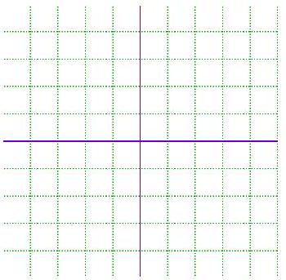

Notice these things about the graph above.
Domain Range $y$-intercept
Horizontal asymptote
Exponential growth
Horizontal line test

As the base, $b$ changes note how little else does.
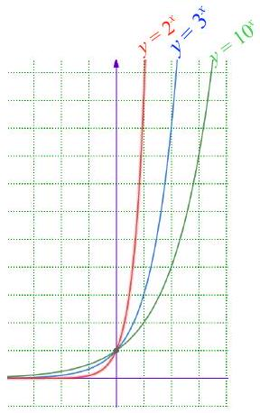
We can use transformations learned previously to graph variations.

EX 2
Use transformations to sketch these functions.
$$f(x)=3^{(x-1)}+2$$ | $$g(x)=2^{(3-x)}-1$$
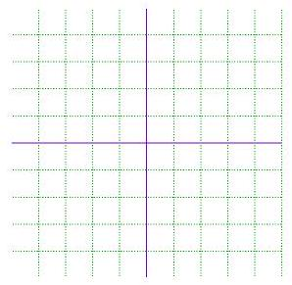

Definition of a Logarithm
For $y>0$ and $b$ a positive constant other than $1, \log_{b}⁡y$ is called a logarithm in base $b$ of $y$, and is the power of $b$ that gives $y$.
$$y=\log_{b}⁡x⇔x=b^{y}$$

EX 3
Find the exact value for each of these.

3a)
$$\log_{2}⁡16$$

3b)
$$\log_{10}⁡100000$$

3c)
$$\log_{5}⁡\frac{1}{125}$$

3d)
$$\log_{8}⁡4$$

EX 4
Convert from logarithmic form to exponential from or visa versa.

4a)
$$9^{3/2}=27$$

4b)
$$\log_{8}⁡\sqrt{8}=\frac{1}{2}$$

4c)
$$\log_{32}⁡4=\frac{2}{5}$$

4d)
$${10}^{-3}=0.001$$

To solve a logarithmic equation, it is convenient to turn it into an exponential equation.

EX 5
Solve each equation.

5a)
$$\log_{2}⁡(x-1)=5$$

5b)
$$\log_{10}⁡(3z)=2$$

Definition of a Logarithmic Function
$f(x)=\log_{b}⁡x$ is a logarithmic function with $x>0,b>0$ and $b≠1$.

EX 6
Fill in the table and sketch a graph of $f(x)=\log_{2}⁡x$

$$x$$ | $$f(x)$$ | $$(x,f(x))$$
$$1/4$$
$$1/2$$
1
2
4
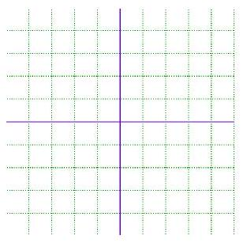

EX 7
Use transformations to sketch $f(x)=-\log_{2}⁡(x)+1$
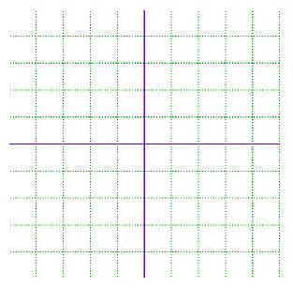

Relationship of Exponential and Logarithmic Functions
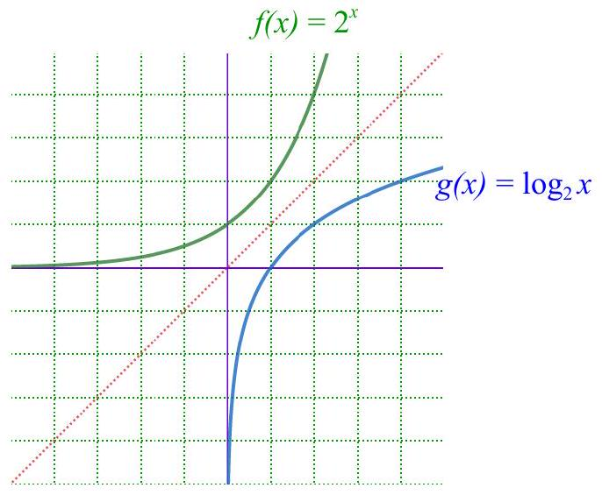

EX 7
Note the symmetry in the two functions. Compute this.
$$(g∘f)(x)=$$

EX 8
All of the previous graphs given in this lesson have the characteristic that $b>1$.
Examine what happens when $0<b<1$. Sketch below for $b=1/2$.

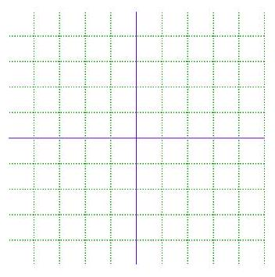
$$f(x)=b^{x},b=1/2$$ | $$f(x)=\log_{b}⁡x,b=1/2$$

Properties of Graphs of Logarithmic And Exponential Functions

