Math 1050 ~ College Algebra

15 Solving Rational Equations and Inequalities

Solving Rational Equations and Inequalities

EX 1
For each of these equations, determine the solution from the graph, then do the algebra to arrive at the same answer.

1a)
$$\frac{x^{2}-1}{x+3}=3$$
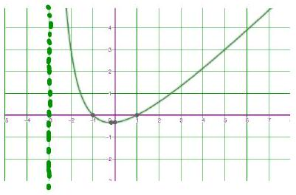

1b)
$$\frac{x-1}{x+1}=1-x$$
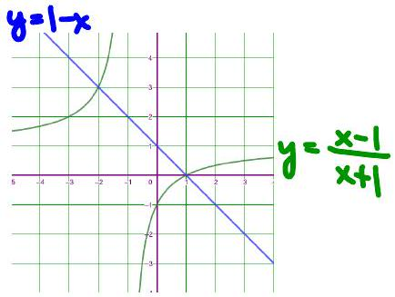

EX 2
Determine the solution graphically and algebraically.
$$\frac{2x^{2}-8}{x^{2}-9}≤0$$
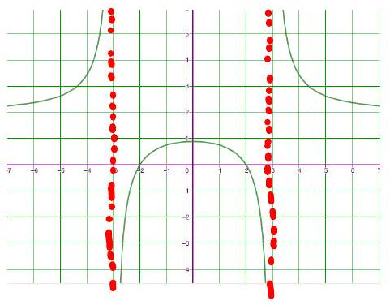

EX 3
Solve algebraically.

3a)
$$\frac{3x}{x-1}≥\frac{x}{x+4}+3$$

3b)
$$\frac{(x-2)(x+1)^{2}}{x(x+1)}≥0$$

EX 4
For each of these inequalities, fill in a sign line.

4a)
$$\frac{3x(x-4)}{(x-1)(x+2)^{2}}≤0$$


4b)
$$\frac{3x(x-4)^{3}}{(x-1)^{2}(x+2)^{2}}≤0$$

4c)
$$\frac{3x(x-4)}{(x-1)^{2}(x+2)^{2}}≤0$$

4d)
$$\frac{3x(x-4)}{(x-1)^{3}(x+2)^{2}}≤0$$

4e)
$$\frac{3x(x-4)^{2}}{(x-1)^{2}(x+2)^{2}}≤0$$

EX 5
A rectangular parking lot with a perimeter of 360 m is to have an area of at least $8000{ m}^{2}$. Within what bounds must the length of the rectangle be?

