Math 1050 ~ College Algebra

14 Graphs with Holes and Variations on Asymptotes

Holes in Rational Functions
Since there can be no points on the vertical asymptotes, what happens in an example like this?

EX 1
Analyze and graph.
$$H(x)=\frac{x-2}{x^{2}-4}$$
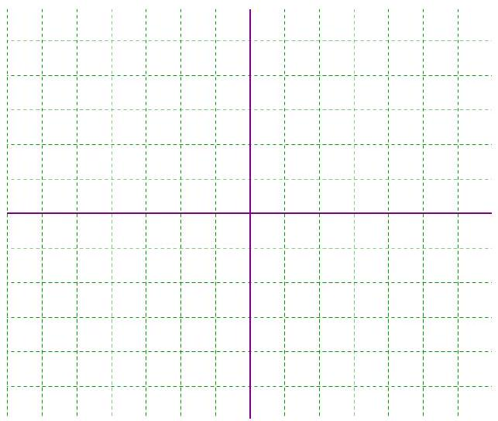

Graphing Rational Functions with No Vertical Asymptotes

EX 2
Analyze and graph. $H(x)=\frac{2x+3}{x^{2}+2}$
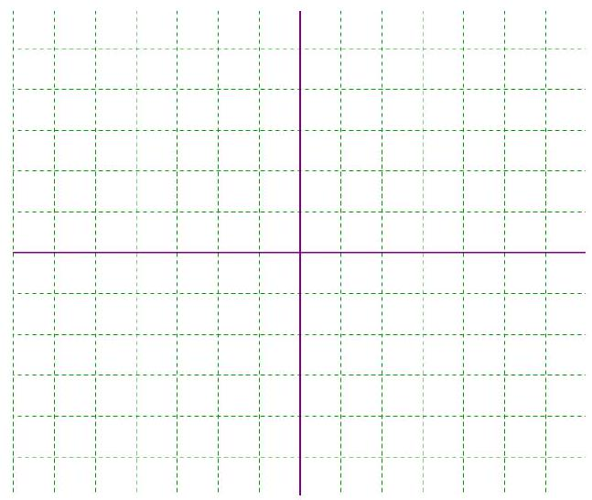

Identifying Slant (Oblique) Asymptotes

EX 3
Analyze and graph.
$$H(x)=\frac{x^{2}-x+6}{x+3}$$
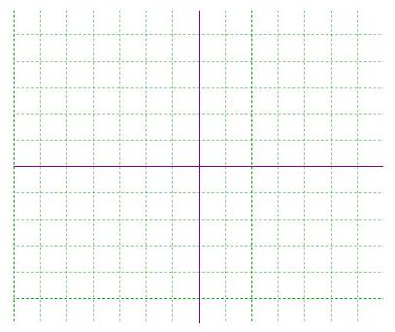

EX 4
Analyze and graph.
$$f(x)=\frac{x^{3}-1}{x-1}$$
