Math 1050 ~ College Algebra

13 Graphing Rational Functions
In our toolkit of functions, we have two rational functions.

EX 1
Sketch these using transformations of the toolkit function.
- $g(x)=\frac{4}{(x+1)}-2$ | - $f(x)=\frac{1}{(x-2)^{2}}+3$
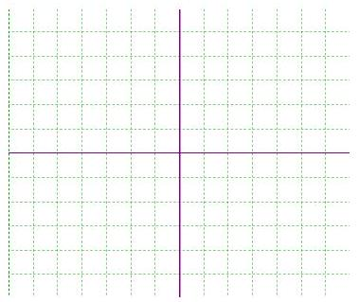

Not all rational functions can be put in this form. It is helpful to follow the steps in the previous lesson to get a graph of a rational function.
- Determine the domain and plot vertical asymptotes.
- Find and plot the x - and y - intercepts.
- Determine and plot the end-behavior asymptotes.
- Use a sign-line and the value of other points to complete the graph.

EX 2
For each of these, determine the x and y -intercepts, vertical and horizontal asymptotes and sketch a graph.
$$f(x)=\frac{3}{1-x}$$ | $$g(x)=\frac{3-x}{x^{2}+4}$$ | $$h(x)=\frac{2x^{2}-5x-3}{x^{2}+x-2}$$
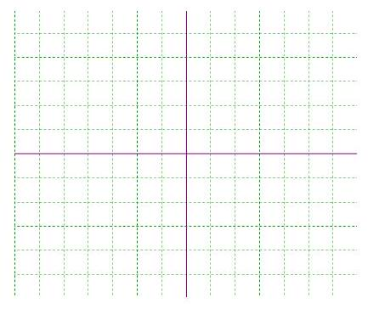

EX 3
Analyze and graph.
$$f(x)=\frac{(x-4)(x-2)^{2}}{(x+3)^{2}(x-1)}$$
