Math 1050 ~ College Algebra

11 Polynomial Inequalities

Graphical Interpretations of Equations and Inequalities

EX 1
Given this graph of $f(x)$ and $g(x)$, determine the values of $x$ for which each of these is true.

1a)
$$f(x)=g(x)$$

1b)
$$f(x)<g(x)$$

1c)
$$f(x)>g(x)$$
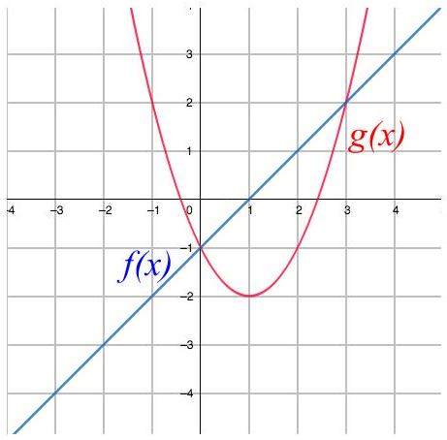

Analytical Solution of Polynomial Inequalities

EX 2
Given $f(x)=x^{2}-4$ and $g(x)=x+2$, determine the values of $x$ for which each of these is true by doing the math.

2a)
$$f(x)=g(x)$$

2b)
$$f(x)<g(x)$$

2c)
$$f(x)>g(x)$$

As the functions get more complicated, it is convenient to use a sign line to sort it out.

Directions for Using a Sign Line
- Write the inequality as a function, $f$, with zero on the right side.
- Determine the zeros of $f$ and place them on a number line.

- Choose a test value in each of the intervals on the number line.
- Determine the sign of $f$ for each test value, writing that sign above that interval.
- Your solution is the interval(s) that correspond to the inequality.

EX 3
Follow the steps above to solve these inequalities.

3a)
$$x^{2}+2x>3$$

3b)
$$-3x^{2}-2x≥-x^{2}+x-2$$

EX 4
Solve this inequality by each method.

4a)
Graphically $(x-1)^{2}-2>-x^{2}+3$

4b)
Analytically $(x-1)^{2}-2>-x^{2}+3$
