Math 1030 #17a
Fundamentals of Geometry
Points, Lines, Planes, Angles

Geometry
some vocabulary
Point

line

plane

dimension

angles

right angle

straight angle

acute angle

obtuse angle

Circle
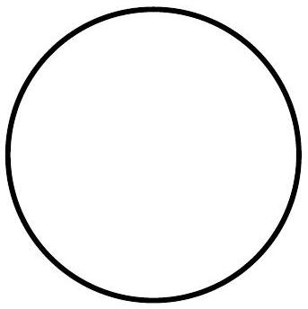

EX 1:
If you have a circular clock, determine the answer to these questions about angles.
- At 5:00 what is the angle between the hands of the clock?
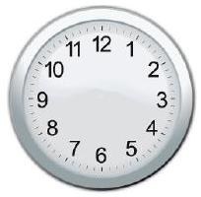
- At what time(s) will the hands of the clock be at an angle of ${120}^{∘}$, assuming it is on the hour?
- What is the angle between the hands of the clock when it is $1:00$ ?

